Preparing and Submitting a Permit Application
This job aide is intended to assist the Preparer or Duly Authorized Representative or Responsible Corporate Officer with creating and/or signing a Class I, Class II, Class III, and Class V Permit Application.

There are several sections to this job aide. Select a hyperlink below to navigate to a specific section:
- UIC Roles
- Creating and/or Updating a Permit Application
- Uploading Documents to the Permit Application
- Navigating the Permit Application and Submitting to EPA
- Reviewing Submitted Permits
- Support
- Index

UIC Roles

- Preparer: Can prepare applications on behalf of their registered organization, however, they cannot sign and submit applications.
- Duly Authorized Representatives (DAR): Can prepare application on behalf of their registered organization, however, they cannot sign and submit applications.
- Responsible Corporate Officer (RCO): Can prepare and electronically sign and submit applications on behalf of their registered organization.

Creating and/or Updating a Permit Application

- Log into the UIC application as a Preparer, Duly Authorized Representative or a Responsible Corporate Officer.
- To create a new permit application, click on the ‘Create Permit Action’ hyperlink on the top navigation on the UIC organization landing page. (see Figure 1).
  - When the user initiates a new permit action, the webform will be blank.
- To open a previously created but not yet submitted permit application, select the ‘Update’ button associated with the desired permit in the Permits Pending Submission table.
  - When the user opens an existing permit action, the webform will contain the previously saved content & files.
Figure 1: Organization Landing Page
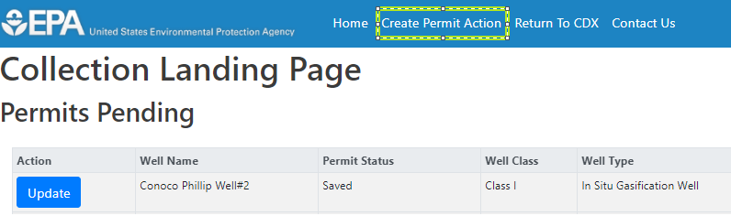

- The first page of the Permit Application will be visible. Complete the application as needed and select the ‘Save and Continue’ button (see Figure 2) to proceed to the Document Upload page.
Figure 2: Webform Navigation Buttons

Uploading Documents to the Permit Application
The document upload page of the webform will allow users to upload all documents that will be necessary for EPA to review the permit application.
The maximum file size for each uploaded file is 200MB. If you would like to include a larger file with your submission, please contact your EPA regional contact.

- Drag and drop a file or select the ‘Select’ button and choose the file from your local hard drive that you would like to upload from the pop-up modal (see Figure 3). Once the file has been selected, click the ‘Open’ button.
  - Multiple files may be uploaded in a single action by selecting multiple files on your local drive and dragging the files into the document upload modal.
- After uploading files, a description may be applied to each of the files in order to better identify attachments.
- If desired, you may select a category for each of the uploaded files in order to better classify each document. A list of the category types can be found in the Instructions for Completing Attachments section below
- Select the ‘Start Upload’ button on the bottom-left of the page to save the uploaded files to your submission (see Figure 3).
- You may remove files by selecting the ‘Remove’ button associated with each file.

Figure 3: Document Upload Page
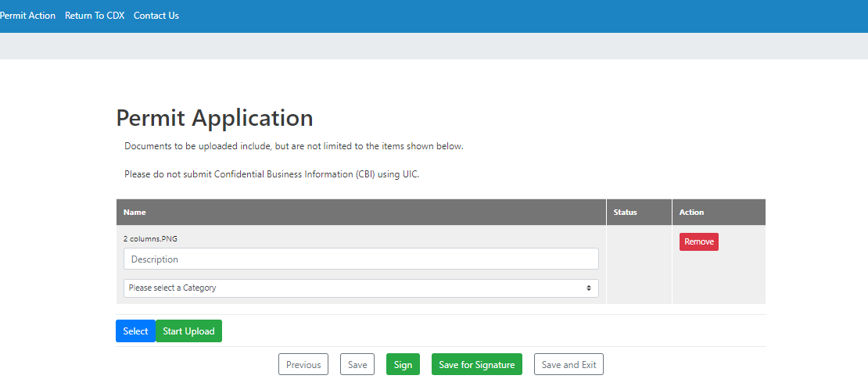

Navigating the Permit Application and Submitting to EPA
- Previous: Ushers the user back to page 1 of the webform
- Save: Saves the user’s progress for the current session. The webform remains open.
- Sign: Initiates the signature and submission process.
  - Only RCO’s can see the “Sign” button
  - When the Sign button is selected, the eSignature Widget is opened and will allow the RCO to apply the password and answer to a security question
- Save for Signature: Saves the content & attached files, closes the webform, and returns you back to the homepage.
  - The permit application can be found in the Permits Pending Submission table.
  - Once the permit is in the Permit Pending Submission table, the RCO for your organization can see that the permit is available for review and subsequent signature per the “Awaiting Verification” Permit Status.
- Save and Exit: Saves the content & attached files and closes the webform.
  - The permit application can be found in the Permits Pending Submission table.
Figure 4: Navigation Buttons

- After selecting the ‘Sign’ button an eSignature Widget will open and will allow the RCO to apply the password and answer to a security question (see Figure 5).

Figure 5: eSignature Widget
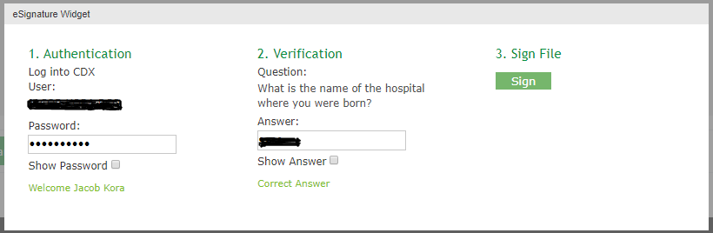
- Enter your CDX password, provide a response to the verification question and select the ‘Sign’ button.
- After the permit application is signed, the webform will close and the permit application will be in the Permits Submitted table on the homepage. The permit is now submitted to EPA for their review.

Reviewing Submitted Permits
- Once the Permit has been signed, the permit application will be available in the Permits Submitted table for Preparer (Organization user), DAR’s (Organization user), RCO’s (Organization user), and Regional Admins (EPA).
- All permit applications that are submitted have been signed by the RCO, and are available for download.
- Click on the link in the “Well Name” column for the desired application.
- A zip file will download once the link within the well name column is selected.

Support
If you have any questions related to CDX or the UIC program service, please contact the CDX Help Desk at helpdesk@epacdx.net or by telephone at 888-890-1995.

Index
Tips for UIC Permit Application Webform:

Latitude: Enter the latitude from the location of the well. Use decimal degrees to five or six places after the decimal, if possible; be sure to include a negative sign for the latitude of a well in the Southern Hemisphere.

Longitude: Enter the longitude from the location of the well. Use decimal degrees to five or six places after the decimal, if possible; be sure to include a negative sign for the longitude of a well in the Western Hemisphere.

SIC Codes: List at least one and no more than four Standard Industrial Classification (SIC) Codes that best describe the nature of the business in order of priority. A list of SIC codes is available from the U.S. Department of Labor at https://www.osha.gov/pls/imis/sicsearch.html.
Indian Country: Select yes if the well is located in Indian country. Indian country (as defined in 18 U.S.C. 1151) includes: all land within the limits of any Indian reservation under the jurisdiction of the U.S. government; all dependent Indian communities within the borders of the U.S.; and all Indian allotments, the Indian titles to which have not been extinguished.
Commercial Facility: Check the appropriate box to indicate the type of facility. A commercial facility is a single or multiple well facility that is specifically engaged in the business of injecting waste fluids generated by third party producers that is originated off-site and transported to the facility by truck for a fee or compensation.

Ownership: Check the appropriate box to indicate whether the owner of the well/facility is a private, Federal, or State/Tribal/Municipal entity.

Type of Permit Action Requested: Check “new permit” if the well has never been subject to a UIC permit (e.g., for a newly constructed or converted well).

Type of Permit: Check “Individual” or “Area” to indicate the type of permit requested. Individual permits cover a single injection well, while area permits may cover more than one injection well. Note that area permits are issued at the discretion of the Director and that wells covered by an area permit must: be at one contiguous site, be under the control of one entity, and may not inject hazardous waste. If an area permit is requested, enter the number of wells to be included in the permit. In the case of a project or field that crosses State lines, it may be possible to consider an area permit if EPA has jurisdiction in all affected States (each such case will be considered individually). Also provide the name of the well field or project.

Surface Field Location: When using the Public Land Survey System, fill in the complete township, range, and section to the nearest quarter-quarter section. A township is north or south of the baseline, and a range is east or west of the principal meridian (e.g., T12N, R34W). Also include the distance, in feet, from the nearest north or south line and nearest east or west line of the quarter-section. For area permit applications, provide the latitude and longitude of the approximate center of the area.
Class and Type of Well: Select the class (as defined in 40 CFR) and type of injection well for which a permit is requested. Use the most pertinent code selected from the options below. When selecting type “Other”, please explain in the space provided.

Well Status: Select Operating if the well currently operates as an injection well (e.g., if a permit renewal is requested or a permit is sought for an existing rule-authorized injection well). Select Conversion for an existing well not currently being utilized for injection that is proposed to be converted to an injection well. Select Proposed for an underground injection well not yet constructed or completed. Provide relevant dates if Operating or Conversion are selected.

API Number: Enter the API number (the number assigned by the local jurisdiction (usually a State Oil and Gas Agency) using the American Petroleum Institute standard numbering system).

Permit or EPA ID number: Enter the Permit or EPA ID number assigned to the injection well by the EPA or the permitting authority. If you do not have a number (e.g., for a new well), this will be provided by EPA or the permitting authority, and you can leave the field blank.

Owner: Enter the name and street address, city/town, state, and ZIP code of the owner of the well, well field, or company. Also provide an email address (if available) and/or a phone number.

Owner Contact Information: Enter the name and street address, city/town, state and ZIP code of the owner of the well, well field, or company. Also provide an email address (if available) and /or a phone number.

Operator: Enter the name and street address, city/town, state, and ZIP code of the operator of well or well field; also provide an email address (if available) and/or a phone number.

Owner Contact Information: Enter the name and street address, city/town, state and ZIP code of the operator of the well, well field; also provide an email address (if available) and /or a phone number. If the operator is the same as the owner, enter “same as owner”.

Instructions for Completing Attachments:

The Underground Injection Control (UIC) program, as promulgated under the Safe Drinking Water Act (SDWA), is designed to prevent injection activity from allowing the movement of fluid containing any contaminant into underground sources of drinking water (USDWs), if the presence of that contaminant may cause a violation of any primary drinking water regulation or may otherwise adversely affect the health of persons as found at Title 40 of the Code of Federal Regulations (40 CFR) section 144.12. Any applicant for a permit under this program shall have the burden of showing that their proposed construction, operation, maintenance, conversion, plugging, abandonment, and injection activity, does not endanger USDWs.

The attachments below have been constructed to provide applicants with clear expectations as to what information EPA needs to make a determination that an applicant’s proposed activities will not endanger USDWs.

Pre-Application Coordination
Coordination between the UIC program and the permit applicant prior to submittal of the permit application is an important step for efficient and effective permitting. Early discussions will ensure that the applicant is aware of all the permit application requirements, including state specific requirements found at 40 CFR part 147. These discussions may also help the applicant plan how to invest time and resources needed to develop a comprehensive and complete permit application.

Applicants are encouraged to contact their EPA regional UIC program for a pre-application coordination meeting. When completing each attachment, please be sure to specify the units reported, e.g., of depth, pressure, temperature, etc.

Attachment A. Map(s) and Area of Review

Part I. Well Location(s)

For Individual Permits: If the surface location provided does not adequately describe the well location (i.e., due to deviation, directional, or horizontal drilling), please describe the well’s orientation and provide the top- and bottom-hole coordinates, as appropriate. If any monitoring wells are proposed as part of this permit application, provide coordinates for all monitoring wells.

For Area Permits (40 CFR): Provide information similar to what is outlined above for individual permits for each well (existing or proposed) to be covered by this permit. In addition, provide a description of the proposed permitted area. At a minimum, this area should include all the proposed or existing wells known at the time of permit application submittal. For circular areas, this description should consist of a defined-radius from a singular point whose coordinates have been given. For polygonal areas, use a series of coordinates describing the vertices or corners of the area. Submit a Geographic Information System (GIS) file, if available.

Part II. Area of Review Size Determination

For All Permits. Give the method (fixed radius or equation) and, if appropriate, all calculations used to determine the size of the area of review (AOR). If you are uncertain as to which method to use, consult with your regional EPA office.

The AOR must be a minimumradius of one-fourth (1/4) mile from the well bore, including a well’s lateral, or the proposed area permit boundary for area permits, unless the use of an equation is approved by the Director.

Part III. Map(s) (40 CFR):

Submit a topographic map (or other map if a topographic map is unavailable) extending one mile beyond the facility property boundary showing:

• Project injection well(s), well pad(s) and/or project area,
• Applicable area of review,
• All outcrops of injection and confining formations,
• All surface water intake and discharge structures, and
• All hazardous waste treatment, storage, or disposal facilities.

Consult with your EPA regional office for the definition of the facility property boundary.

Within the one-fourth (1/4) mile beyond the facility property boundary or the AOR, whichever is larger, the map will also show the:

• Name and location of all production wells, injection wells, abandoned wells, dry holes, and all water wells, noting their types (public water system, domestic drinking water, stock, etc.),
• Springs and surface bodies of water,
• Mines (surface and subsurface) and quarries, and
• Other pertinent surface features, including residences, schools, hospitals, and roads.

Only information of public record and pertinent information known to the applicant is required to be included on this map. Multiple maps may be needed to display this information clearly. If a certain feature is not present in the area covered, please state so definitively (e.g., “There are no known outcrops of the confining formation in the mapped area.”).

Part IV. Area of Review Wells and Corrective Action Plans (40 CFR)

Submit a tabulation of data and wellbore diagrams reasonably available from public records or otherwise known to the applicant on all wells within the AOR included on the map, which penetrate the proposed confining zone(s). Such information will include:

• Well name, location and depth,
• Well type,
• Date well was drilled,
• Well construction that includes casing and cement details, including demonstrated or calculated top of cement,
• Cement bond logs (if available), and
• Record of well completion and plugging (if applicable).

For such wells which are improperly sealed, completed, or abandoned, also submit a plan consisting of such steps or modifications as are necessary to prevent movement of fluid into USDWs.

Part V. Landowners Information (40 CFR)

Identify and submit a list with the names and addresses of all owners of record of land within one-fourth (1/4) mile of the facility property boundary. This requirement may be waived by the Regional Administrator if the site is in a populous area and the Regional Administrator determines that the requirement would be impracticable.

Consult with your regional EPA office, as additional state landowner notification requirements may apply (40 CFR part 147).

Attachment B. Geological and Geophysical Information

Part I. Geological Data

Provide the following information:

• Geological data on all formations from the surface to the base of the injection well, identifying all USDWs and confining and injection zone(s). This data includes the lithologic description, geological name, thickness, depth, and total dissolved solids (TDS) concentrations from these formations (if known),
• The position of all USDWs that may be affected by the proposed injection relative to the injection formation and the direction of water movement,
• The geologic structure of the local area,
• Source of information for the geologic data and formation TDS,
• Porosity and permeability of injection formation (if available),
• Geological cross-sections proximate to the injection well that include the confining and injection zones. The cross-sections should illustrate the regional geologic setting and show the thickness and lateral continuity of the confining zone(s) through the area of review,
• Within the AOR, identify known or suspected faults and fracture systems. If identified, provide proximity to the injection zone and the effect the fault/fracture system may have on the injection activities, and
• A history of seismic activity in the area and proximity to crystalline (i.e., granitic) basement.

Part II. Proposed Formation Testing Program

Provide a formation testing program to obtain data on:

• Fluid pressure,
• Temperature,
• Estimated fracture pressure,
• Physical and chemical characteristics of the formation fluids, and
• Physical and chemical characteristics of the injection zone.

Attachment C. Well Construction/Conversion Information

Part I. Well Schematic Diagram (40 CFR)

Provide a detailed proposed well schematic diagram that includes:

•Identification of USDWs and confining and injection zones,
•Casing and cementing details, including demonstrated or calculated top of cement,
•Tubing and packer (if applicable),
•Open hole or perforated intervals,
•Proposed injection procedures including pump, surge, tank, and
•Surface trace (if horizontal or deviated well).

For wells that are drilled and to be converted to an injection well, also provide the current well schematic diagram.

Part II. Well Construction or Conversion Procedures (40 CFR)

Provide a detailed description of well construction or conversion procedures that includes:

• Proposed logs and other tests conducted during the drilling and construction of new well(s),
• Proposed stimulation plan(s), if planned, and
• Description of alarms and shut-down systems at the well (if applicable).
For wells that are drilled and to be converted to an injection well, also provide:
• Well completion and cementing records, and
• Previously run logs/tests.

Attachment D. Injection Operation and Monitoring Program (40 CFR)

Submit the following information:

• Flow diagram of fluid flow through the facility,
• Contingency plan(s) to cope with well failure, so as to prevent migration of contaminating fluids into a USDW,
• Drawing of the surface construction,
• Locations of all monitoring devices (show on the map(s) referenced in section A.III. above), and
• Description of sampling and monitoring devices to monitor the nature of the injected fluids, injection pressure, annulus pressure (if applicable), flowrate, and cumulative volume.

Additionally, submit the following proposed operating data for each well in the individual or area permit:

• Average and maximum daily rate and volume of fluids to be injected,
• Average and maximum injection pressure,
• Source of injection fluids (including field and formation names),
• Proposed annular fluid, and
• Analysis of the chemical and physical characteristics of the injection fluid. At a minimum, this should include pH, specific gravity, TDS, and conductivity. Consult with the regional EPA office for additional guidance.

Attachment E. Plugging and Abandonment Plan (40 CFR)

Submit a plugging and abandonment (P&A) plan of the well along with a P&A diagram. The plan should include:

• Type, and number of plugs to be used,
• Placement of each plug including the elevation of top and bottom,
• Type, grade, and quantity of cement to be used, and
• Method of placement of the plugs.

Provide one or more cost estimates from an independent firm in the business of plugging and abandoning wells to conduct the work proposed in the P&A plan for EPA to contract plugging of the well. This is to ensure that EPA has adequate funding to plug the well(s) if the operator is unable to plug the well(s).

Consult with the regional EPA office for additional guidance on developing the P&A plan and cost estimate calculations.

Attachment F. Financial Assurance (40 CFR)

Submit evidence of financial resources, such as a surety bond or financial statement, necessary for a third party to close, plug, or abandon the well in the event an owner or operator is unable to do so. The monetary amount is based on the P&A plan cost estimate provided in Attachment E.

Attachment G. Site Security and Manifest Requirements (Commercial Wells Only)

Provide a proposed site security plan. This could include fencing around the perimeter of the facility. Consult with the regional EPA office for additional guidance on manifest requirements.

Attachment H. Aquifer Exemptions (40 CFR)

If an aquifer exemption (AE) is requested, submit the information required at 40 CFR and to demonstrate that the criteria found at 40 CFR are met. Consult with your regional EPA office for additional guidance.

Attachment I. Existing EPA Permits (40 CFR)

Submit a listing of all permits or construction approvals received or applied for under any of the following programs:

• Hazardous Waste Management program under RCRA,
• UIC program under SDWA,
• NPDES program under CWA,
• Prevention of Significant Deterioration (PSD) program under the Clean Air Act,
• Nonattainment program under the Clean Air Act,
• National Emission Standards for Hazardous Pollutants (NESHAPS) preconstruction approval under the Clean Air Act.
• Ocean dumping permits under the Marine Protection Research and Sanctuaries Act,
• Dredge and fill permits under section 404 of CWA, and
• Other relevant environmental permits, including State permits.

Attachment J. Description of Business (40 CFR)

Provide a brief description of the nature of the business.

Attachment K. Optional Additional Project Information (40 CFR)

The following is a list of Federal laws that may apply prior to the issuance of permits. When any of these laws are applicable, EPA must ensure that they are followed. The optional additional information requested below will assist EPA in its analyses to satisfy these laws.
• The Wild and Scenic Rivers Act, 16 U.S.C. 1273 et seq.
Identify any national wild and scenic river that may be impacted by the activities associated with the proposed project.
•The National Historic Preservation Act of 1966, 16 U.S.C. 470 et seq.
Identify properties listed or eligible for listing in the National Register of Historic Places that may be affected by the activities associated with the proposed project. If previous historic and cultural resource survey(s) have been conducted, provide the results of the survey(s).
•The Endangered Species Act,16 U.S.C. 1531 et seq.
Identify any endangered or threatened species that may be affected by the activities associated with the proposed project. If a previous endangered or threatened species survey has been conducted, provide the results of the survey.
•The Coastal Zone Management Act, 16 U.S.C. 1451 et seq.
Identify any coastal zones that may be affected by the activities associated with the proposed project.

